EUID: kmh0497

Valid JWK Found In JWKS (Below)

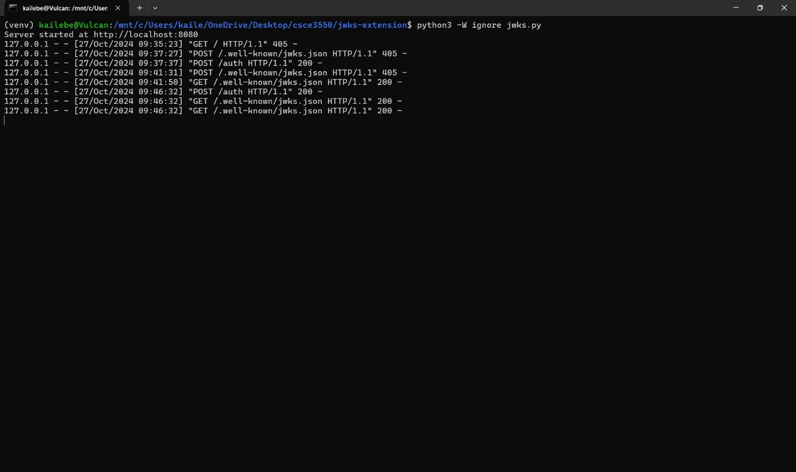

Gradebot Project2 Test Client Screenshot (Below)

Test Suite Screenshot (Below)

